Sugar Smart Case Studies

Chef’s Sugar Smart Tips  Meet Tim Radcliffe from @ELHT.NHS, who, along with his catering team, is driving quality, sustainability and promoting healthier options. Recent winners of the NHS Chef of the Year award, the Trust has built an enviable reputation for healthy, tasty food and is leading the way in promoting healthier, low sugar drink options in its catering and retail offer.  Tim shares his top tips for your organisation to pledge support for #SugarSmart:  - Create a plan and set some goals – with timescales  - Limit or stop promotion on high fat/salt/sugar items  - Reduce confectionary calories – we started with nothing over 250 calories and now we create our own healthier options  - Promote healthier options for impulse purchases and eyeline sales  - Review vending offer – ours in now 40% healthier  - Consider a sugar levy – ours is 20p for the highest sugar options  - Meat free Monday is always a popular offer and is a great way to inspire patients and staff with tasty veggie ideas  - Review Portion sizes | 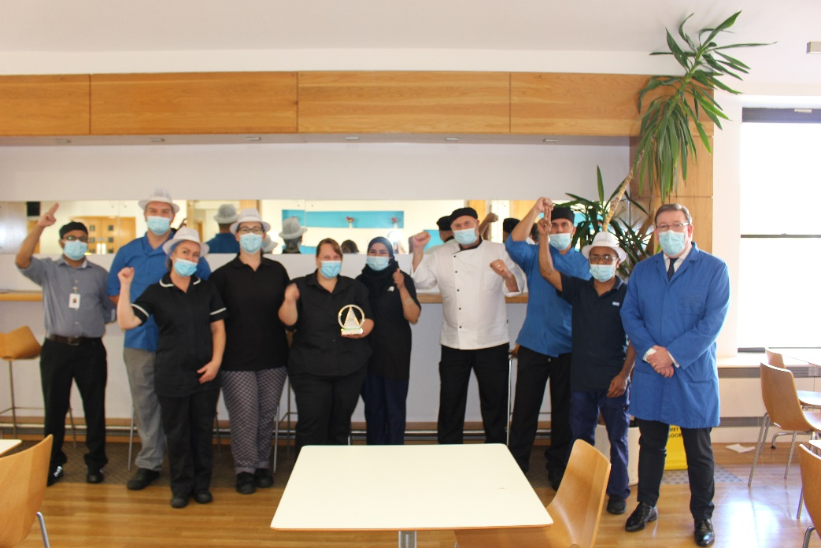
Pledge to be Sugar Smart  Our #SugarSmart partner, @ELHT.NHS East Lancashire Hospitals NHS Trust has proved that a commitment to healthier options and a reduction in sugar isn’t a compromise on quality and taste.  Chefs Sanish Thomas and Sinto Mulavarickal have been crowned National NHS Chef of the Year and the duo make everything fresh just like hotels and restaurants do.  The chefs cook fresh and nothing is reheated or frozen. They source high quality ingredients including British meat and free-range eggs.  As well as meat free Mondays which serves up vegan dishes, the Trust has reviewed its entire catering and retail service and is committed to promoting healthier, low sugar options in its food and drink offer.  Inspired? Pledge to support Blackburn’s bid to become Lancashire’s first #SugarSmart town.Food Map Form - Be Well BWD | 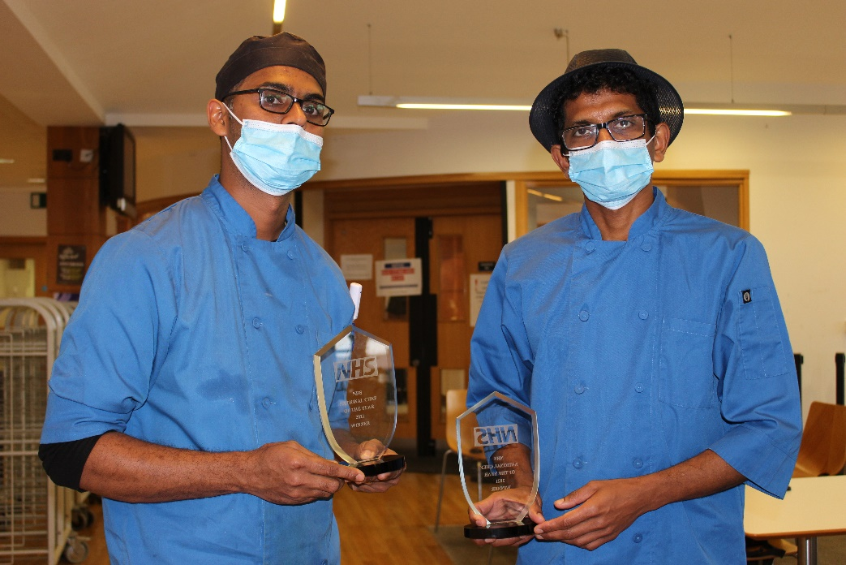
Get Involved  If you’re wondering how to join our #SugarSmart campaign then look no further than the multi award-winning Catering Department at East Lancashire Hospitals NHS Trust.  It is one of only 14 Trusts nationally to have joined the NHS Exemplary Trusts Programme and Hospital Food Network, sharing best practice.  Recognised for their innovation, high food standards and consistent service, the Trust has also been at the forefront of a drive to promote and support healthier choices for patients, visitors and staff.  Why not make a plan and try and inspire your employees, team or colleagues to make healthier choices at work – or play! For ideas on how to make a difference check out: https://www.sugarsmartuk.org/get_involved/ | 