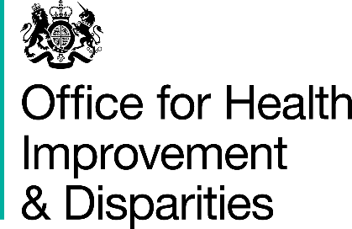

## National Dental Survey, 2023 to 2024

### I have read and understood the information for parents and people with parental responsibility.

### I agree to my child having a dental check as part of the national dental survey 2023 to 2024

### Child’s name: ________________________________________________­­­

### Child’s date of birth: __________________________________________

### Child’s home postcode: _______________________________________

### Childs's Ethnicity:____________________________________________

### Name of parent or person with parental responsibility: _____________

### Signature of parent or person with parental responsibility:

### ____________________________________________________________

### Date:________________________________________________________

### Please return this form to your child’s school. Thank you.